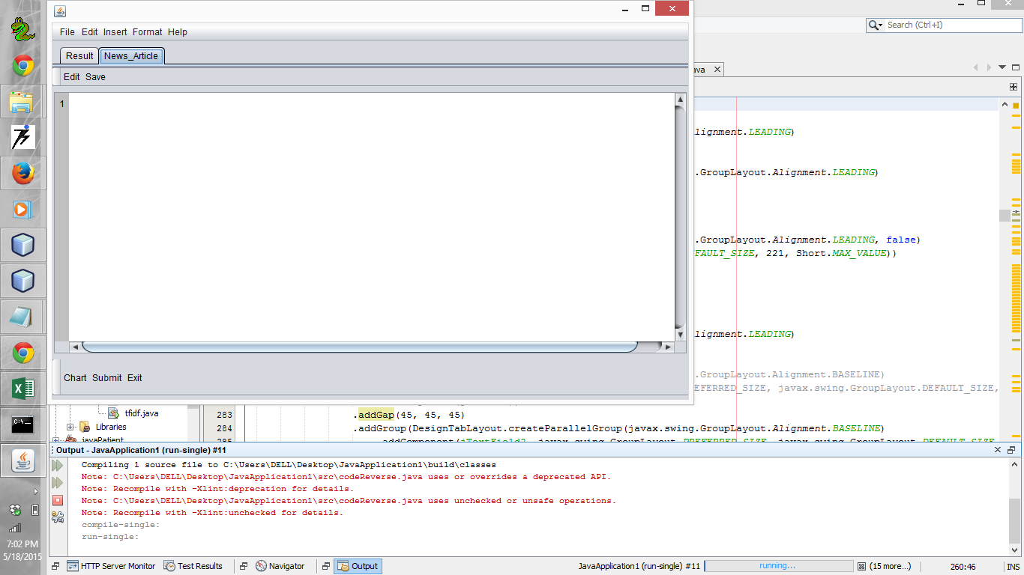

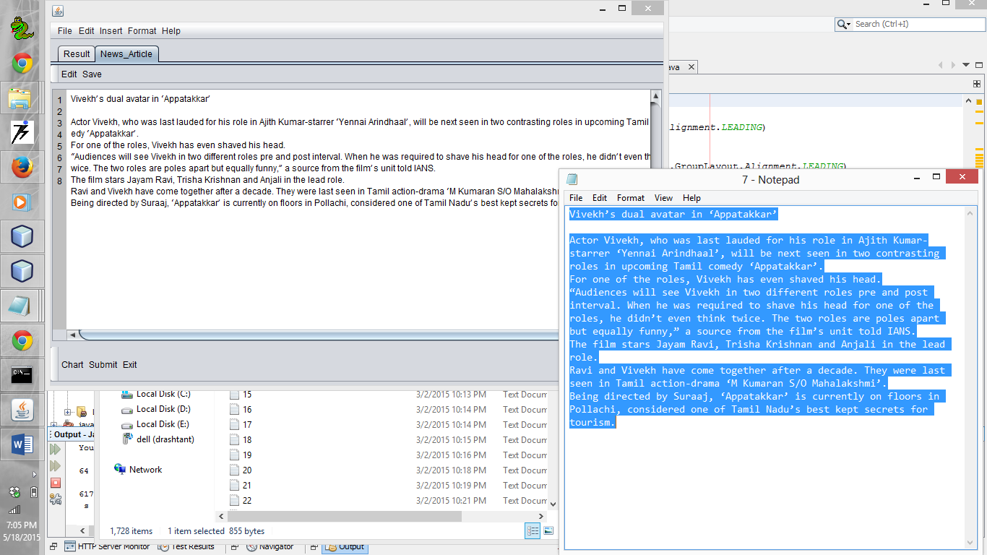

ant -f C:\\Users\\DELL\\Desktop\\JavaApplication1 -Djavac.includes=codeReverse.java -Dnb.internal.action.name=run.single -Drun.class=codeReverse run-single

init:

Deleting: C:\Users\DELL\Desktop\JavaApplication1\build\built-jar.properties

deps-jar:

Updating property file: C:\Users\DELL\Desktop\JavaApplication1\build\built-jar.properties

Compiling 1 source file to C:\Users\DELL\Desktop\JavaApplication1\build\classes

Note: C:\Users\DELL\Desktop\JavaApplication1\src\codeReverse.java uses or overrides a deprecated API.

Note: Recompile with -Xlint:deprecation for details.

Note: C:\Users\DELL\Desktop\JavaApplication1\src\codeReverse.java uses unchecked or unsafe operations.

Note: Recompile with -Xlint:unchecked for details.

compile-single:

run-single:

Reading POS tagger model from taggers/wsj-0-18-bidirectional-nodistsim.tagger ... done [0.5 sec].

s

was

lauded

be

seen

contrasting

upcoming

has

shaved

see

was

required

shave

think

are

s

told

stars

have

come

were

seen

Being

directed

is

considered

s

kept

Vivekh

avatar

Appatakkar

Actor

Vivekh

role

Ajith

Kumar

starrer

Yennai

Arindhaal

roles

Tamil

comedy

Appatakkar

roles

Vivekh

head

Audiences

Vivekh

roles

pre

post

interval

head

roles

roles

poles

source

film

unit

IANS

The

film

Jayam

Ravi

Trisha

Krishnan

Anjali

role

Ravi

Vivekh

decade

Tamil

action

drama

M

Kumaran

S

O

Mahalakshmi

Suraaj

Appatakkar

floors

Pollachi

Tamil

Nadu

secrets

tourism

Oracle JDBC Driver Registered!

You made it, take control your database now!

490

Oracle JDBC Driver Registered!

You made it, take control your database now!

Oracle JDBC Driver Registered!

You made it, take control your database now!

Oracle JDBC Driver Registered!

You made it, take control your database now!

Oracle JDBC Driver Registered!

You made it, take control your database now!

Oracle JDBC Driver Registered!

You made it, take control your database now!

Oracle JDBC Driver Registered!

You made it, take control your database now!

Oracle JDBC Driver Registered!

You made it, take control your database now!

Oracle JDBC Driver Registered!

You made it, take control your database now!

Oracle JDBC Driver Registered!

You made it, take control your database now!

Oracle JDBC Driver Registered!

You made it, take control your database now!

Oracle JDBC Driver Registered!

You made it, take control your database now!

Oracle JDBC Driver Registered!

You made it, take control your database now!

Oracle JDBC Driver Registered!

You made it, take control your database now!

Oracle JDBC Driver Registered!

You made it, take control your database now!

Oracle JDBC Driver Registered!

You made it, take control your database now!

Oracle JDBC Driver Registered!

You made it, take control your database now!

Oracle JDBC Driver Registered!

You made it, take control your database now!

Oracle JDBC Driver Registered!

You made it, take control your database now!

Oracle JDBC Driver Registered!

You made it, take control your database now!

Oracle JDBC Driver Registered!

You made it, take control your database now!

Oracle JDBC Driver Registered!

You made it, take control your database now!

Oracle JDBC Driver Registered!

You made it, take control your database now!

Oracle JDBC Driver Registered!

You made it, take control your database now!

Oracle JDBC Driver Registered!

You made it, take control your database now!

Oracle JDBC Driver Registered!

You made it, take control your database now!

Oracle JDBC Driver Registered!

You made it, take control your database now!

Oracle JDBC Driver Registered!

You made it, take control your database now!

Oracle JDBC Driver Registered!

You made it, take control your database now!

Oracle JDBC Driver Registered!

You made it, take control your database now!

Oracle JDBC Driver Registered!

You made it, take control your database now!

Oracle JDBC Driver Registered!

You made it, take control your database now!

Oracle JDBC Driver Registered!

You made it, take control your database now!

Oracle JDBC Driver Registered!

You made it, take control your database now!

Oracle JDBC Driver Registered!

You made it, take control your database now!

Oracle JDBC Driver Registered!

You made it, take control your database now!

Oracle JDBC Driver Registered!

You made it, take control your database now!

Oracle JDBC Driver Registered!

You made it, take control your database now!

Oracle JDBC Driver Registered!

You made it, take control your database now!

Oracle JDBC Driver Registered!

You made it, take control your database now!

Oracle JDBC Driver Registered!

You made it, take control your database now!

Oracle JDBC Driver Registered!

You made it, take control your database now!

Oracle JDBC Driver Registered!

You made it, take control your database now!

Oracle JDBC Driver Registered!

You made it, take control your database now!

Oracle JDBC Driver Registered!

You made it, take control your database now!

Oracle JDBC Driver Registered!

You made it, take control your database now!

Oracle JDBC Driver Registered!

You made it, take control your database now!

Oracle JDBC Driver Registered!

You made it, take control your database now!

Oracle JDBC Driver Registered!

You made it, take control your database now!

Oracle JDBC Driver Registered!

You made it, take control your database now!

Oracle JDBC Driver Registered!

You made it, take control your database now!

Oracle JDBC Driver Registered!

You made it, take control your database now!

Oracle JDBC Driver Registered!

You made it, take control your database now!

Oracle JDBC Driver Registered!

You made it, take control your database now!

Oracle JDBC Driver Registered!

You made it, take control your database now!

Oracle JDBC Driver Registered!

You made it, take control your database now!

Oracle JDBC Driver Registered!

You made it, take control your database now!

Oracle JDBC Driver Registered!

You made it, take control your database now!

Oracle JDBC Driver Registered!

You made it, take control your database now!

Oracle JDBC Driver Registered!

You made it, take control your database now!

Oracle JDBC Driver Registered!

You made it, take control your database now!

Oracle JDBC Driver Registered!

You made it, take control your database now!

Oracle JDBC Driver Registered!

You made it, take control your database now!

Oracle JDBC Driver Registered!

You made it, take control your database now!

Oracle JDBC Driver Registered!

You made it, take control your database now!

Oracle JDBC Driver Registered!

You made it, take control your database now!

Oracle JDBC Driver Registered!

You made it, take control your database now!

Oracle JDBC Driver Registered!

You made it, take control your database now!

Oracle JDBC Driver Registered!

You made it, take control your database now!

Oracle JDBC Driver Registered!

You made it, take control your database now!

Oracle JDBC Driver Registered!

You made it, take control your database now!

Oracle JDBC Driver Registered!

You made it, take control your database now!

Oracle JDBC Driver Registered!

You made it, take control your database now!

Oracle JDBC Driver Registered!

You made it, take control your database now!

Oracle JDBC Driver Registered!

You made it, take control your database now!

Oracle JDBC Driver Registered!

You made it, take control your database now!

Oracle JDBC Driver Registered!

You made it, take control your database now!

Oracle JDBC Driver Registered!

You made it, take control your database now!

Oracle JDBC Driver Registered!

You made it, take control your database now!

Oracle JDBC Driver Registered!

You made it, take control your database now!

Oracle JDBC Driver Registered!

You made it, take control your database now!

Oracle JDBC Driver Registered!

You made it, take control your database now!

Oracle JDBC Driver Registered!

You made it, take control your database now!

Oracle JDBC Driver Registered!

You made it, take control your database now!

Oracle JDBC Driver Registered!

You made it, take control your database now!

Oracle JDBC Driver Registered!

You made it, take control your database now!

Oracle JDBC Driver Registered!

You made it, take control your database now!

Oracle JDBC Driver Registered!

You made it, take control your database now!

490

Oracle JDBC Driver Registered!

You made it, take control your database now!

Oracle JDBC Driver Registered!

You made it, take control your database now!

SPORTS

87 64

498

role 7.0

TF =0.08045977011494253

IDF =2.991724252156452

TFIDF =8.424970595153226

vivekh 5.0

s 4.0

TF =0.04597701149425287

IDF =3.0325462466767075

TFIDF =3.903967581928635

appatakkar 3.0

tamil 3.0

TF =0.034482758620689655

IDF =4.601162164590552

TFIDF =4.601162164590552

seen 2.0

shave 2.0

head 2.0

TF =0.022988505747126436

IDF =2.298577071596507

TFIDF =3.22329198545717

wa 2.0

ravi 2.0

TF =0.022988505747126436

IDF =4.264689927969339

TFIDF =1.3725438848636953

film 2.0

TF =0.022988505747126436

IDF =5.111987788356544

TFIDF =0.5875848032593729

arindhaal 1.0

anjali 1.0

m 1.0

TF =0.011494252873563218

IDF =3.8127048042262826

TFIDF =0.7011870904324198

tourism 1.0

think 1.0

TF =0.011494252873563218

IDF =3.075105861095503

TFIDF =0.883651109510202

have 1.0

TF =0.011494252873563218

IDF =6.210600077024653

TFIDF =0.07138620778189256

trisha 1.0

o 1.0

TF =0.011494252873563218

IDF =3.502549875922443

TFIDF =1.046739043379121

be 1.0

TF =0.011494252873563218

IDF =6.210600077024653

TFIDF =0.14277241556378512

upcome 1.0

TF =0.011494252873563218

IDF =5.517452896464707

TFIDF =0.12683799761987832

are 1.0

TF =0.011494252873563218

IDF =6.210600077024653

TFIDF =0.07138620778189256

come 1.0

TF =0.011494252873563218

IDF =5.111987788356544

TFIDF =0.17627544097781186

avatar 1.0

unit 1.0

TF =0.011494252873563218

IDF =3.5715427474093944

TFIDF =0.7389398787743574

krishnan 1.0

floor 1.0

TF =0.011494252873563218

IDF =3.4380113547848716

TFIDF =0.9879342973519747

see 1.0

star 1.0

TF =0.011494252873563218

IDF =2.2216160304603783

TFIDF =1.7619713345030585

direct 1.0

TF =0.011494252873563218

IDF =4.601162164590552

TFIDF =0.26443460716037653

is 1.0

TF =0.011494252873563218

IDF =5.111987788356544

TFIDF =0.17627544097781186

pre 1.0

TF =0.011494252873563218

IDF =4.264689927969339

TFIDF =0.3921553956753415

action 1.0

TF =0.011494252873563218

IDF =2.843304247038179

TFIDF =1.013131398369926

were 1.0

kept 1.0

kumar 1.0

TF =0.011494252873563218

IDF =3.3202283191284883

TFIDF =1.1830698608388865

comedy 1.0

the 1.0

TF =0.011494252873563218

IDF =1.5471609829125859

TFIDF =2.2940662850083173

kumaran 1.0

pollachi 1.0

laud 1.0

contraste 1.0

told 1.0

audience 1.0

TF =0.011494252873563218

IDF =5.111987788356544

TFIDF =0.17627544097781186

post 1.0

TF =0.011494252873563218

IDF =2.776612872539507

TFIDF =1.3723488910252737

mahalakshmi 1.0

nadu 1.0

TF =0.011494252873563218

IDF =4.601162164590552

TFIDF =1.533720721530184

ha 1.0

TF =0.011494252873563218

IDF =5.517452896464707

TFIDF =0.12683799761987832

considere 1.0

actor 1.0

TF =0.011494252873563218

IDF =5.517452896464707

TFIDF =0.12683799761987832

starrer 1.0

yennai 1.0

requir 1.0

secret 1.0

TF =0.011494252873563218

IDF =4.824305715904762

TFIDF =0.2218071593519431

suraaj 1.0

decade 1.0

TF =0.011494252873563218

IDF =4.264689927969339

TFIDF =0.3921553956753415

jayam 1.0

ians 1.0

source 1.0

TF =0.011494252873563218

IDF =4.131158535344817

TFIDF =0.5698149703923885

pole 1.0

TF =0.011494252873563218

IDF =5.517452896464707

TFIDF =0.25367599523975665

interval 1.0

TF =0.011494252873563218

IDF =5.517452896464707

TFIDF =0.12683799761987832

ajith 1.0

bee 1.0

TF =0.011494252873563218

IDF =5.517452896464707

TFIDF =0.12683799761987832

drama 1.0

TF =0.011494252873563218

IDF =4.601162164590552

TFIDF =0.26443460716037653

total TFIDF =39.437320198792285

Oracle JDBC Driver Registered!

You made it, take control your database now!

POLOTICAL

87 64

490

role 7.0

TF =0.08045977011494253

IDF =2.5568192313782867

TFIDF =10.697496554272371

vivekh 5.0

s 4.0

TF =0.04597701149425287

IDF =2.8985685251003432

TFIDF =4.264560588653379

appatakkar 3.0

tamil 3.0

TF =0.034482758620689655

IDF =3.3040336332085074

TFIDF =6.949863849162723

seen 2.0

shave 2.0

head 2.0

TF =0.022988505747126436

IDF =3.8918202981106265

TFIDF =0.984138466188894

wa 2.0

ravi 2.0

TF =0.022988505747126436

IDF =4.114963849424837

TFIDF =0.9459687010172038

film 2.0

TF =0.022988505747126436

IDF =4.248495242049359

TFIDF =1.0743321301734012

arindhaal 1.0

anjali 1.0

TF =0.011494252873563218

IDF =6.194405391104672

TFIDF =0.07120006196672037

m 1.0

TF =0.011494252873563218

IDF =2.302585092994046

TFIDF =1.9849871491327982

tourism 1.0

TF =0.011494252873563218

IDF =5.501258210544727

TFIDF =0.12646570598953397

think 1.0

TF =0.011494252873563218

IDF =4.584967478670572

TFIDF =0.26350387808451564

have 1.0

TF =0.011494252873563218

IDF =5.501258210544727

TFIDF =0.12646570598953397

trisha 1.0

o 1.0

TF =0.011494252873563218

IDF =3.997180813768453

TFIDF =0.5053906776029078

be 1.0

TF =0.011494252873563218

IDF =6.194405391104672

TFIDF =0.07120006196672037

upcome 1.0

are 1.0

TF =0.011494252873563218

IDF =5.501258210544727

TFIDF =0.12646570598953397

come 1.0

avatar 1.0

TF =0.011494252873563218

IDF =6.194405391104672

TFIDF =0.07120006196672037

unit 1.0

TF =0.011494252873563218

IDF =2.5568192313782867

TFIDF =1.2931039790878691

krishnan 1.0

floor 1.0

TF =0.011494252873563218

IDF =3.997180813768453

TFIDF =0.5972798917125274

see 1.0

TF =0.011494252873563218

IDF =6.194405391104672

TFIDF =0.07120006196672037

star 1.0

TF =0.011494252873563218

IDF =4.402645921876617

TFIDF =0.4554461298493052

direct 1.0

TF =0.011494252873563218

IDF =3.1986731175506815

TFIDF =0.8456262264789158

is 1.0

pre 1.0

TF =0.011494252873563218

IDF =3.997180813768453

TFIDF =0.4135014634932882

action 1.0

TF =0.011494252873563218

IDF =2.3877429013343527

TFIDF =1.9760630907594643

were 1.0

kept 1.0

kumar 1.0

TF =0.011494252873563218

IDF =2.205421344540398

TFIDF =3.59965322901996

comedy 1.0

the 1.0

TF =0.011494252873563218

IDF =1.4670175723923318

TFIDF =2.445029287320553

kumaran 1.0

pollachi 1.0

laud 1.0

contraste 1.0

told 1.0

audience 1.0

TF =0.011494252873563218

IDF =3.6294560336431356

TFIDF =0.6257682816626096

post 1.0

TF =0.011494252873563218

IDF =2.4102157571864113

TFIDF =1.966957686899255

mahalakshmi 1.0

nadu 1.0

TF =0.011494252873563218

IDF =3.421816668864891

TFIDF =1.2979304606039241

ha 1.0

considere 1.0

actor 1.0

TF =0.011494252873563218

IDF =4.402645921876617

TFIDF =0.6072615064657403

starrer 1.0

yennai 1.0

requir 1.0

secret 1.0

TF =0.011494252873563218

IDF =6.194405391104672

TFIDF =0.07120006196672037

suraaj 1.0

decade 1.0

TF =0.011494252873563218

IDF =3.7965101183063017

TFIDF =0.48001852070539447

jayam 1.0

ians 1.0

source 1.0

TF =0.011494252873563218

IDF =1.7057690213725325

TFIDF =3.0978333951363233

pole 1.0

TF =0.011494252873563218

IDF =6.194405391104672

TFIDF =0.07120006196672037

interval 1.0

ajith 1.0

bee 1.0

TF =0.011494252873563218

IDF =5.501258210544727

TFIDF =0.18969855898430094

drama 1.0

TF =0.011494252873563218

IDF =4.114963849424837

TFIDF =0.3783874804068815

total TFIDF =48.746398672643444

Oracle JDBC Driver Registered!

You made it, take control your database now!

ENTERTAINMENT

87 64

491

role 7.0

TF =0.08045977011494253

IDF =1.2764632019663957

TFIDF =24.85435246127672

vivekh 5.0

TF =0.05747126436781609

IDF =6.19644412779452

TFIDF =1.7805873930444025

s 4.0

TF =0.04597701149425287

IDF =3.060949911865371

TFIDF =4.362733207716161

appatakkar 3.0

TF =0.034482758620689655

IDF =6.19644412779452

TFIDF =0.6410114614959849

tamil 3.0

TF =0.034482758620689655

IDF =2.97756830292632

TFIDF =5.236413222387666

seen 2.0

shave 2.0

head 2.0

TF =0.022988505747126436

IDF =3.306072369898356

TFIDF =1.5200332735164854

wa 2.0

ravi 2.0

TF =0.022988505747126436

IDF =5.097831839126411

TFIDF =0.46876614612656653

film 2.0

TF =0.022988505747126436

IDF =0.5580894584607748

TFIDF =13.676399142969792

arindhaal 1.0

TF =0.011494252873563218

IDF =5.097831839126411

TFIDF =0.8789365239873123

anjali 1.0

TF =0.011494252873563218

IDF =6.19644412779452

TFIDF =0.0712234957217761

m 1.0

TF =0.011494252873563218

IDF =3.9992195504583012

TFIDF =0.4596804080986553

tourism 1.0

TF =0.011494252873563218

IDF =6.19644412779452

TFIDF =0.0712234957217761

think 1.0

TF =0.011494252873563218

IDF =4.250533978739207

TFIDF =0.3419969867951086

have 1.0

TF =0.011494252873563218

IDF =5.503296947234575

TFIDF =0.1265125734996454

trisha 1.0

TF =0.011494252873563218

IDF =4.81014976667463

TFIDF =0.2764453888893465

o 1.0

TF =0.011494252873563218

IDF =3.71153747800652

TFIDF =0.7252429554725384

be 1.0

TF =0.011494252873563218

IDF =6.19644412779452

TFIDF =0.0712234957217761

upcome 1.0

TF =0.011494252873563218

IDF =4.58700621536042

TFIDF =0.26362104685979426

are 1.0

come 1.0

avatar 1.0

TF =0.011494252873563218

IDF =3.9992195504583012

TFIDF =0.5056484489085208

unit 1.0

TF =0.011494252873563218

IDF =4.81014976667463

TFIDF =0.2211563111114772

krishnan 1.0

TF =0.011494252873563218

IDF =5.097831839126411

TFIDF =0.17578730479746246

floor 1.0

TF =0.011494252873563218

IDF =3.6314947703329836

TFIDF =0.5843784687892157

see 1.0

TF =0.011494252873563218

IDF =4.58700621536042

TFIDF =0.3690694656037119

star 1.0

TF =0.011494252873563218

IDF =1.3136422052081498

TFIDF =2.838675110104967

direct 1.0

TF =0.011494252873563218

IDF =2.6129251893384104

TFIDF =1.261412160370267

is 1.0

TF =0.011494252873563218

IDF =4.250533978739207

TFIDF =0.43971041159371105

pre 1.0

TF =0.011494252873563218

IDF =4.404684658566466

TFIDF =0.607542711526409

action 1.0

TF =0.011494252873563218

IDF =2.641096066305107

TFIDF =1.4571564503752312

were 1.0

kept 1.0

kumar 1.0

TF =0.011494252873563218

IDF =2.730708224994794

TFIDF =1.4752101905144286

comedy 1.0

TF =0.011494252873563218

IDF =2.346296526084462

TFIDF =2.8856750378280167

the 1.0

TF =0.011494252873563218

IDF =1.6966344574642556

TFIDF =2.379188549547577

kumaran 1.0

TF =0.011494252873563218

IDF =6.19644412779452

TFIDF =0.0712234957217761

pollachi 1.0

TF =0.011494252873563218

IDF =6.19644412779452

TFIDF =0.0712234957217761

laud 1.0

contraste 1.0

told 1.0

audience 1.0

TF =0.011494252873563218

IDF =2.171092437059371

TFIDF =2.3707331209268996

post 1.0

TF =0.011494252873563218

IDF =2.762456923309374

TFIDF =1.1113332450095184

mahalakshmi 1.0

TF =0.011494252873563218

IDF =6.19644412779452

TFIDF =0.0712234957217761

nadu 1.0

TF =0.011494252873563218

IDF =5.503296947234575

TFIDF =0.1265125734996454

ha 1.0

TF =0.011494252873563218

IDF =6.19644412779452

TFIDF =0.1424469914435522

considere 1.0

actor 1.0

TF =0.011494252873563218

IDF =0.844585994318454

TFIDF =4.0190643867567815

starrer 1.0

TF =0.011494252873563218

IDF =3.060949911865371

TFIDF =0.8795833080072906

yennai 1.0

TF =0.011494252873563218

IDF =5.097831839126411

TFIDF =0.8789365239873123

requir 1.0

secret 1.0

TF =0.011494252873563218

IDF =3.79854885499615

TFIDF =0.6112607352867369

suraaj 1.0

TF =0.011494252873563218

IDF =6.19644412779452

TFIDF =0.0712234957217761

decade 1.0

TF =0.011494252873563218

IDF =3.1519216900710973

TFIDF =0.8332666536969568

jayam 1.0

TF =0.011494252873563218

IDF =6.19644412779452

TFIDF =0.0712234957217761

ians 1.0

TF =0.011494252873563218

IDF =2.2074600812302463

TFIDF =1.395520741007627

source 1.0

TF =0.011494252873563218

IDF =2.641096066305107

TFIDF =1.5178713024741992

pole 1.0

TF =0.011494252873563218

IDF =6.19644412779452

TFIDF =0.0712234957217761

interval 1.0

TF =0.011494252873563218

IDF =5.503296947234575

TFIDF =0.1265125734996454

ajith 1.0

TF =0.011494252873563218

IDF =5.097831839126411

TFIDF =0.8789365239873123

bee 1.0

TF =0.011494252873563218

IDF =5.503296947234575

TFIDF =0.1265125734996454

drama 1.0

TF =0.011494252873563218

IDF =2.4587745095111524

TFIDF =1.3848270225982353

total TFIDF =87.85767255038452

Oracle JDBC Driver Registered!

You made it, take control your database now!

490

Oracle JDBC Driver Registered!

You made it, take control your database now!

64

61745 5990

s wa laud be seen contraste upcome ha shave see wa requir shave think are s told star have come were seen bee direct is considere s kept vivekh avatar appatakkar actor vivekh role ajith kumar starrer yennai arindhaal role tamil comedy appatakkar role vivekh head audience vivekh role pre post interval head role role pole source film unit ians the film jayam ravi trisha krishnan anjali role ravi vivekh decade tamil action drama m kumaran s o mahalakshmi suraaj appatakkar floor pollachi tamil nadu secret tourism

